IT 315 Final Project Part I Solution Submission Template

Name: Dominique Goncalves
Date: 3-19-2017

This template is a guide for you to organize your information. Some information may be too large or too small for the area in which it is intended. Resize or rearrange the area as necessary.

1. | Generate your student information system (SIS) use case diagram. Copy and paste your diagram here:  SIS Use Case Diagram:  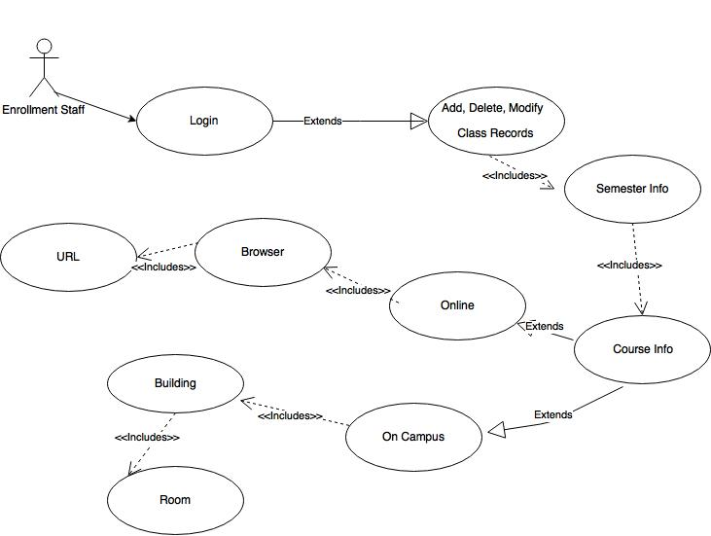
1. | Using this use case description template, provide a description for each use case in your use case diagram:  Use Case 1 Description: Staff Modifying Class Information
  Use Case Name: Maintain Class Records | ID: | Importance Level: High
  Primary Actor:  Staff | Use Case Type:  Essential
  Stakeholders and Interests: Staff updating and maintaining class records
  Brief Description: Describes how staff will log in and update class records
  Trigger Class records that need to be updated or changed by staff
  Type: internal
  Relationships:
  - Association: Enrollment Staff
  - Include: Add, Modify, Delete, class records, semester info, course location
  - Extend: Class records
  - Generalization:
  Normal Flow of Events:
  1.Staff logs in and needs to modify, add, delete class location
  2.Semester is selected
  3. Course
  4. Class location
  5. Add, Modify, Delete
  SubFlows:
  S1-Add
  1.Staff logs in and needs to add class l
  2.Semester is selected
  3. Course Name
  4. Class location
  5. Adds Class
  S2- Modify
  1.Staff logs in and needs to modify class location
  2.Semester is selected
  3. Course
  4. Class location
  5. Modify Class
  S3-Delete
  1.Staff logs in and needs to delete class
  2.Semester is selected
  3. Course
  4. Class location
  5., Delete Class
  Alternate/Exceptional Flows:
2. | Verify and validate your use case diagram and use case descriptions against the SIS requirements definition:  Starting from the beginning of the diagram. I moved through the steps of adding, modifying, and deleting a class.
3. | Explain your approach to the problem, the decisions you made to arrive at your solution, and how you completed it:  I started at the beginning of the definitions and worked my way through. I am now sketching the diagrams by hand prior to drawing them
4. | Reflect on this experience and the lessons you learned from it:  After completing the first assignment this one didn’t seem as difficult

IT 315 Final Project Part I Solution Submission Template

Name: Dominique Goncalves
Date: 3-19-2017

This template is a guide for you to organize your information. Some information may be too large or too small for the area in which it is intended. Resize or rearrange the area as necessary.

1. | Generate your student information system (SIS) use case diagram. Copy and paste your diagram here:  SIS Use Case Diagram:  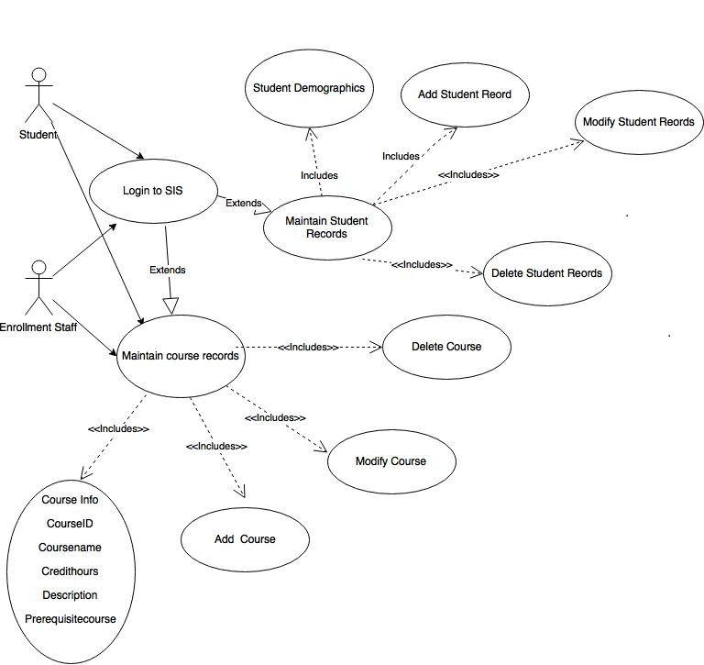
1. | Using this use case description template, provide a description for each use case in your use case diagram:  Use Case 1 Description: Staff Modifying Student Information
  Use Case Name: Maintain Student Records | ID: | Importance Level: High
  Primary Actor:  Staff and Student | Use Case Type:  Essential
  Stakeholders and Interests: Students and Staff
  Brief Description: Student and staff maintaining student records by adding deleting, and modifying
  Trigger Student records that need to be updated or changed by staff or student
  Type: internal and External
  Relationships:
  - Association: Student and Staff
  - Include: Add, Modify, Delete, Student Information
  - Extend: login, student records
  - Generalization:
  Normal Flow of Events:
  Staff or Student logs in and needs to modify, add, delete student information
  SubFlows:
  Information added to system by student or staff needs to be updated and or removed
  Alternate/Exceptional Flows:
2. | Verify and validate your use case diagram and use case descriptions against the SIS requirements definition:  Starting from the beginning of the diagram. I moved through the steps of adding, modifying, and deleting student information
3. | Explain your approach to the problem, the decisions you made to arrive at your solution, and how you completed it:  I started at the beginning of the definitions and worked my way through. Step by step how a student or staff member would add, modify or delete information
4. | Reflect on this experience and the lessons you learned from it:  After completing the first assignment this one didn’t seem as difficult

IT 315 Final Project Part I Solution Submission Template

Name: Dominique Goncalves
Date: 3-19-2017

This template is a guide for you to organize your information. Some information may be too large or too small for the area in which it is intended. Resize or rearrange the area as necessary.

1. | Generate your student information system (SIS) use case diagram. Copy and paste your diagram here:  SIS Use Case Diagram:  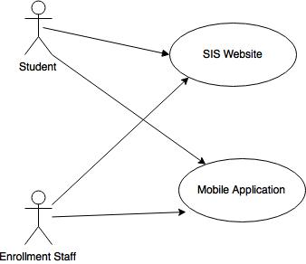
1. | Using this use case description template, provide a description for each use case in your use case diagram:  Use Case 1 Description: Student and or Staff logging into SIS system
  Use Case Name: Access SIS | ID: | Importance Level: High
  Primary Actor:  Student and Staff | Use Case Type:  Essential
  Stakeholders and Interests: Students and Enrollment Staff wanting to access sis
  Brief Description: this use case describes how student and staff will access the sis system
  Trigger: Student information needs to be updated, student or staff needs to access student information center
  Type: internal and external
  Relationships:
  - Association: Student or Enrollment Staff
  - Include:
  - Extend: application or website
  - Generalization:
  Normal Flow of Events:
  1. Student needs to access SIS system
  2. logs into mobile application
  S-1 logs into website
  1. Staff needs to access SIS system
  2. logs into website
  SubFlows:
  Alternate/Exceptional Flows:
  1. Student needs to access SIS system
  2. logs into website
2. | Verify and validate your use case diagram and use case descriptions against the SIS requirements definition:  Student selects mode they would like to access sis system via either mobile app or website
3. | Explain your approach to the problem, the decisions you made to arrive at your solution, and how you completed it:  Very simple use case on how to access the sis system
4. | Reflect on this experience and the lessons you learned from it:  After completing the first assignment this one didn’t seem as difficult

IT 315 Final Project Part I Solution Submission Template

Name: Dominique Goncalves
Date: 3-19-2017

This template is a guide for you to organize your information. Some information may be too large or too small for the area in which it is intended. Resize or rearrange the area as necessary.

1. | Generate your student information system (SIS) use case diagram. Copy and paste your diagram here:  SIS Use Case Diagram:  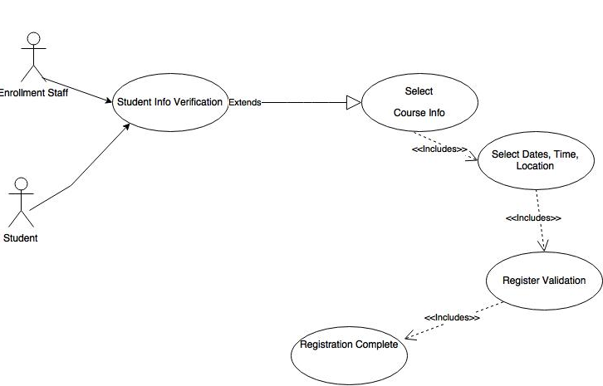
1. | Using this use case description template, provide a description for each use case in your use case diagram:  Use Case 1 Description: Student Class Registration
  Use Case Name:  Student Class Registration | ID: | Importance Level:  High
  Primary Actor:  Student and Staff | Use Case Type:  Essential
  Stakeholders and Interests: Students and Staff
  Brief Description: Students registering for classes via SIS
  Trigger: Students regestering for classes via SIS alne or with the help of enrollment staff
  Type: External and Internal
  Relationships:
  - Association: Student and Staff
  Include: Course info, Class location, time and date
  - Extend: student validation
  - Generalization:
  Normal Flow of Events:
  1.Student validates identity
  2.Selects Course
  3.Location, date, and time
  4.Registration confirmation
  5.Registaration complete
  SubFlows:
  S1-Staff assisted
  1.Staff validates student’s identity
  2.Selects Course
  3.Location, date, and time
  4.Registration confirmation
  5.Registaration complete
  Alternate/Exceptional Flows:
2. | Verify and validate your use case diagram and use case descriptions against the SIS requirements definition:  Starting from the beginning of the diagram working my way to the end  The student information is entered to identify the registering student.  The course information for which to register is entered to identify the course.  All future classes with start dates after the current date for this course are displayed.  The selected class registration is then validated against the following registration rules:  When the class registration is validated against the above rules, a confirmation is then displayed to confirm registration. Otherwise, a message explaining the violation of the associated rule is displayed.  The process continues, starting from the beginning, until the user ends the session.
3. | Explain your approach to the problem, the decisions you made to arrive at your solution, and how you completed it:  This process is very similar to the process I currently use to register for classes. So, I drew from that process when creating this diagram.
4. | Reflect on this experience and the lessons you learned from it:  This diagram was simple to make, I could have went into much more detail on the registration processes making it a longer diagram, but decided to hit upon the key points of student registration.

